## 实验二 Introduction to Classes and Objects

## 学号: 09017423 姓名：杨彬

### 实验目的

Objectivities

1. How to define a class and use it to create an object

2. How to define member functions in a class to implement the class’s behaviors.

3. How to declare data members in a class to implement the class’s attributes

4. How to call a member function of an object to make that member function perform its task.

5. The differences between data members of a class and local variables of a function.

6. How to use a constructor to ensure that an object’s data is initialized when the object is created.

7. How to engineer a class to separate its interface from its implementation and encourage reuse.

（目标

1。如何定义一个类并用它来创建一个对象

2。如何定义类中的成员函数来实现类的行为。

3.如何在类中声明数据成员以实现类的属性

4。如何调用一个对象的成员函数，使该成员函数执行其任务。

5。类的数据成员和函数的局部变量之间的差异。

6。如何使用构造函数确保在创建对象时对象的数据被初始化。

7。如何设计一个类，使其接口与实现分离，并鼓励重用。）

### 二、实验内容

Exp1

Description of the Problem Modify class GradeBook (Figs. 3.11 and Figs. 3.12). Include a second string data member that represents the name of the course’s instructor. Provide a set function to change the instructor’s name and a get function to retrieve it. Modify the constructor to specify two parameters—one for the course name and one for the instructor’s name. Modify member function display Message such that it first outputs the welcome message and course name, then outputs "This course is presented by: " followed by the instructor’s name. Modify the test application to demonstrate the class’s new capabilities.

Exp2

1. Class Employee should declare three data members. 2. The constructor must declare three parameters, one for each data member. The value for the salary should be validated to ensure it is not negative. 3. Declare a public set and get functions for each data member. The set functions should not return values and should each specify a parameter of a type that matches the corresponding data member (string for first name and last name, int for the salary). The get functions should receive no parameters and should specify a return type that matches the corresponding data member. 4. When you call the constructor from the main function, you must pass it three arguments that match the parameters declared by the constructor. 5. Giving each employee a raise will require a call to the get function for the salary to obtain the current salary and a call to the set function for the salary to specify the new salary. 6. Be sure to follow the spacing and indentation conventions mentioned in the text. 7. If you have any questions as you proceed, ask your lab instructor for help.

### 三、实验代码及结果：

源代码

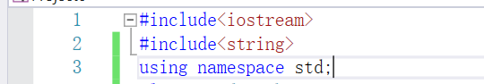

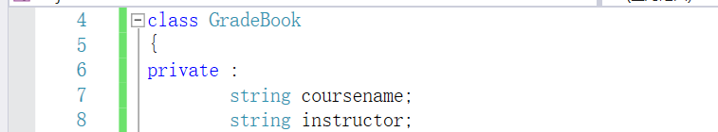

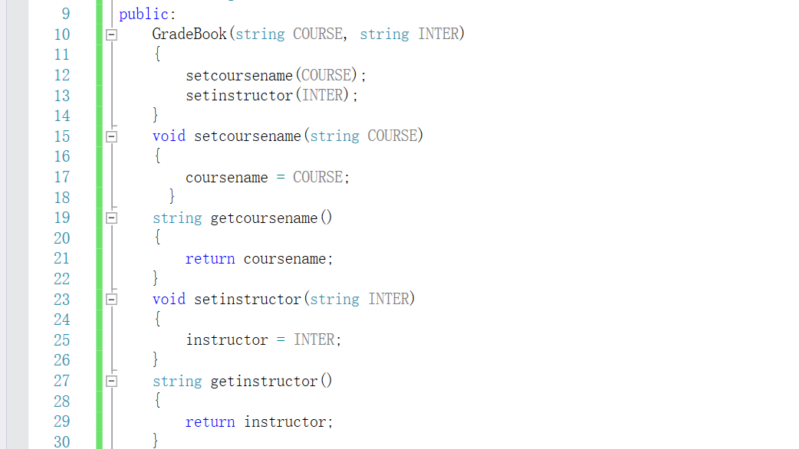

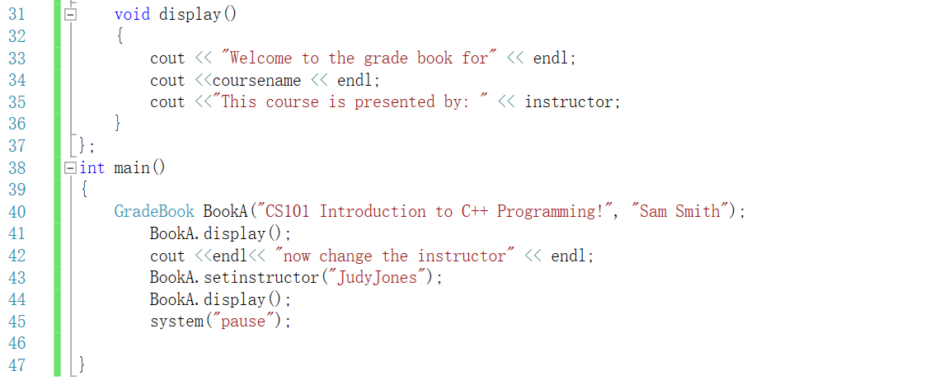

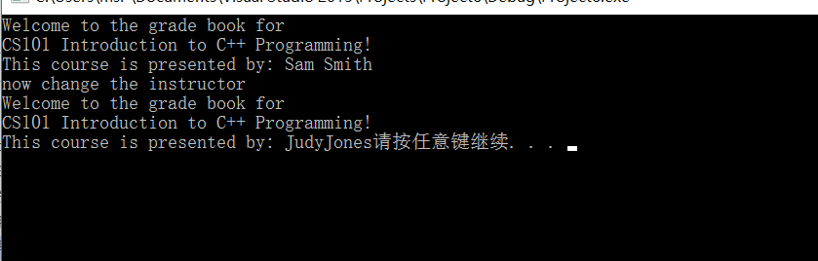

Exp2

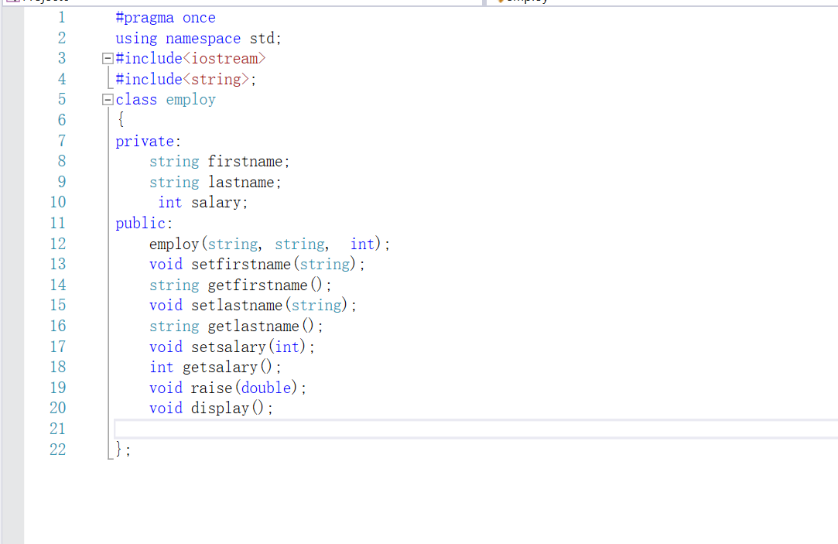

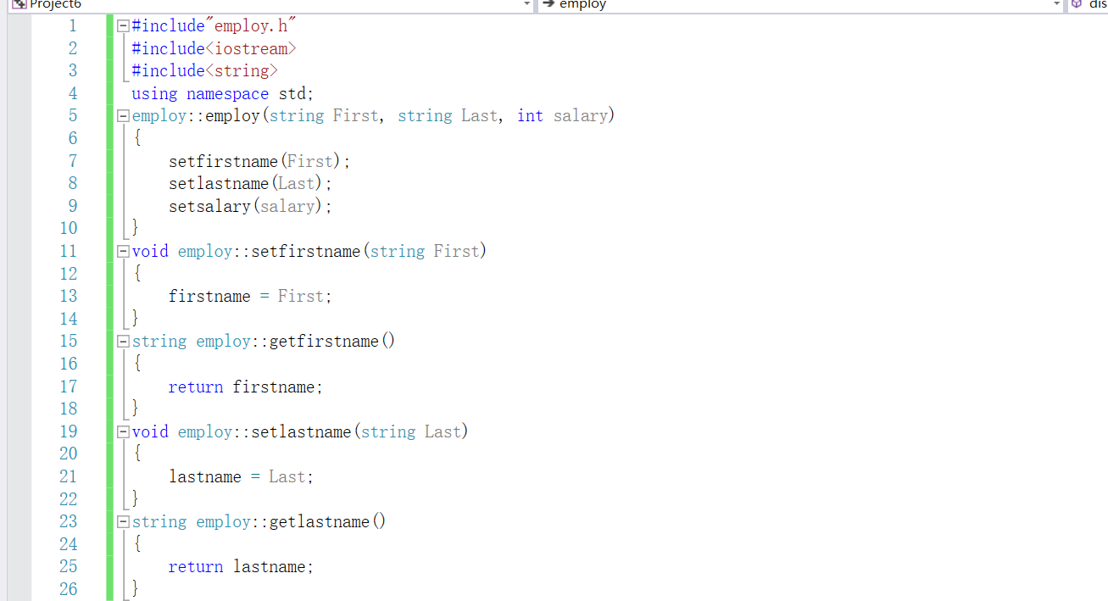

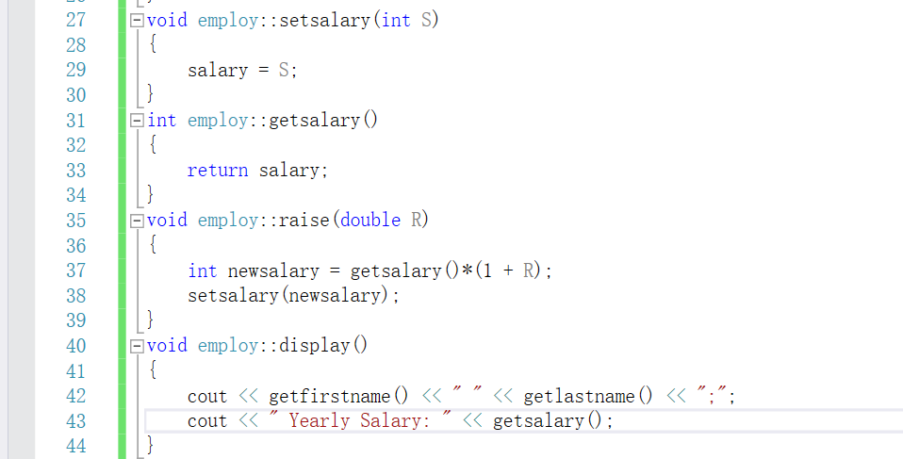

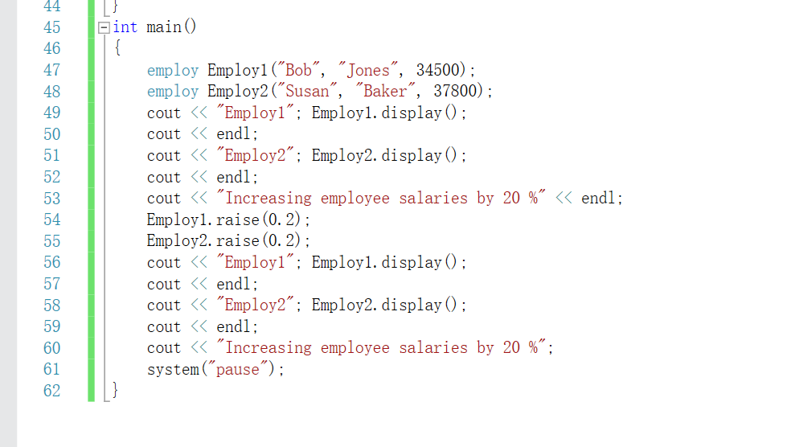

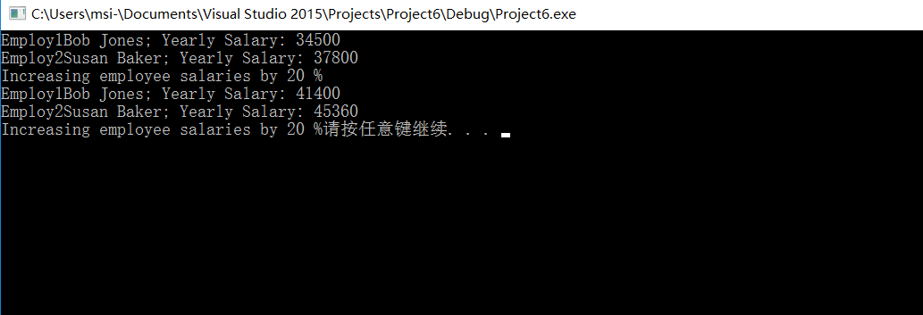

### 四、遇到的问题及解决过程

Exp1 nothing

Exp2 nothing

### 五、实验体会

Exp1 通过本实验第一次创建了一个类，初步掌握了类的声明，建立构造函数，private变量，调用类对象中的函数以及通过set函数和get函数来获得或者得到类对象中的变量

Exp2 在这个实验中我进一步熟悉了类的创建，同时我尝试着在创建类的时候使用头文件的结构。将定义与声明分开。